Report 2: A Survey of ERP systems

By

Mr. WARIS DAMKHAM 6388014

Mr. THANAWATH HUAYHONGTHONG 6388016

Miss PATTANAN KORKIATTRAKOOL 6388022

Mr. NAPHAT SOOKJITSUMRAN 6388059

**Submitted to  
Assoc. Prof. Dr. Jarernsri Mitrpanont**

A Report Submitted in Partial Fulfillment of

the Requirements for

ITCS 414 – Information Retrieval and Storage

Faculty of Information and Communication Technology

Mahidol University

2021

**Executive Summary page**

The group report 2 of ITCS361 Management Information System, the report on Enterprise Applications, ERP systems, and important features in applications   
The report consists of:   
- Software Architecture   
- Software Module   
- A crucial feature of each tool   
- How to use the tool   
- Advantages and disadvantages   
This report is to achieve the objectives of the study report to study the three applications of ERP systems and their important features.

**Table of Contents**

**Enterprise Application** 1

**Concept** 1

**Challenges** 1

**Enterprise Resource Planning (E.R.P.) Systems** 2

**Concept** 2

**Challenges** 2

**The business value ERP** 3

**Trends of ERP** 3

**Tool1 – SAP** 6

**Software architecture** 6

**Presentation Layer** 7

**Application Layer** 8

**Database Layer** 8

**SAP Modules** 9

**Important features** 11

**How to use SAP tool** 12

**The Pros and Cons of SAP ERP Systems** 19

**Pros** 19

**Cons** 19

**Company or organizations that use SAP** 20

**Tool 2 – Odoo** 21

**Software architecture** 21

**Presentation tier** 21

**Logic tier** 21

**Data tier** 21

**Odoo Modules** 22

**Important features** 22

**How to use Odoo tool** 24

**The Pros and Cons of Odoo ERP Systems** 29

**Pros** 29

**Cons** 29

**Company or organizations that use Odoo** 30

**Tool 3 – Microsoft Dynamics 365** 31

**Software architecture** 31

**Application object server (AOS)** 31

**Enterprise Portal** 31

**Enterprise Search** 31

**Software modules** 32

**Important features** 34

**How to use Microsoft Dynamics 365 tool** 36

**Pro and Cons** 38

**Pros** 38

**Cons** 38

**Company or organizations that use them** 38

**A Comparison table of the tools** 39

**Discussion** 40

**Conclusion** 41

**References** 42

# **Enterprise Application**

## **Concept**

The concept of Enterprise Applications is designed to integrate computer systems used to work in every step of the organization to facilitate the cooperation and coordination of work throughout the organization. The purpose of Enterprise Applications is to integrate core business processes. An ideal enterprise system can control all critical business processes in real time through an integrated software architecture on a client/server platform. Enterprise software is expanding to connect organizations with suppliers, business partners, and customers.

## **Challenges**

Enterprise application development must satisfy the needs of a business organization, not an individual. Developing this type of instrument is tricky. It requires more than meticulous planning and ability. Both business requirements and surroundings are in constant flux. The market is always evolving. The expectations of businesses may change over time and frequently differ significantly from their initial state. As a company grows, it may face significant scaling issues, posing a formidable obstacle that is difficult to handle without incurring losses. Therefore, adaptability and flexibility are essential non-functional requirements for every business software. Protection and access management When employing corporate software, users frequently interact with sensitive data, which should be restricted to authorized users only. Any software product may be a target for attacks and breaches, and security processes are one of the most challenging issues for firms to manage. Therefore, all applicable preventive actions must be implemented to secure firm data.

# **Enterprise Resource Planning (E.R.P.) Systems**

## **Concept**

The concept of Enterprise resource planning systems are integrated business management software systems that can efficiently collect, store, manage, and interpret data and information from various business processes. These include financial management accounting, human resource allocation, manufacturing, and distribution operations.

## **Challenges**

ERP adoption is challenging since it is a complicated, enterprise-wide procedure. It causes a paradigm change in working practices by paving the way for automation as opposed to manual operations. It requires that all parties tackle the problem of ERP installation and include users and functional groups in the creation of the new solution. As the commitment of top management is required to overcome such challenges, the company need a specialized project team to represent all ERP platform users. Thus, it emphasizes the necessity of business process requirements across all organizational hierarchies and divisions.

# **The business value ERP**

The ERP system serves as a tool to drive improvement and to create or maintain an organization's competitive advantage. The ERP system serves to change the organization's information to be more accurate and timelier. That allows businesses to react quickly and appropriately to ever-changing business conditions. The business value of ERP systems is their ability to create a seamless integration of business processes within the organization to improve workflow and accomplish real-time and accurate information availability and allow the sharing and dissemination of information efficiently within the organization through their well-documented process. The ERP system will help the organization better understand and react to its current business conditions.

# **Trends of ERP**

Example of ERP that will matter most in the future of ERP market:

* **The internet of things (IOT)**

The internet of things (IOT) is the connectivity between computers and other devices. IoT provides improved asset management, greater efficiency, improved forecasting, real-time business insights, enhanced communication, improved business intelligence, real-time analytics, artificial intelligence (AI), e-commerce retail and more. Among the mentioned factors, has necessitated a growing IoT presence in the business world. IoT integration will be seen everywhere within the ERP software industry and become an asset for ERP software buyers.

* **Two-Tier ERP**

Two-tier ERP is a concept where mid-sized and small companies are combined solutions concurrently. It’s also accessible to companies that have multiple locations or subsidiaries. This system type is on the rise because of the increasing number of companies seeking these systems. This ties in with cloud computing and, in general, makes ERP systems more accessible for all companies. Due to a surge in digital transformation and e-commerce, businesses today require mobility.

* **Cloud ERP**

Small businesses profit most from cloud-based ERP since they no longer need to maintain their own systems, which significantly reduces the requirement for in-house IT. Cloud Deployment makes it possible for small companies with just a few IT employees to take advantage of an ERP system, so the small company wouldn’t be able to afford to maintain.

* **Digital Transformation**

Digital transformation refers to the process of incorporating digital technology into all corporate tasks to enhance daily operations. This strategy may frequently increase income and competitiveness, as well as improve staff productivity, customer service, and communication.

* **Other Technology Integrated With ERP**

Modern ERP is a key component of a company's digital transformation, but it is only a portion of a larger investment in technology. To enhance fundamental operations, businesses are combining their business apps with other emerging technologies, such as IoT. Retailers, for instance, utilize warehouse management systems that collect data from mobile scanners and intelligent conveyers to monitor the flow of items within the warehouse. Some businesses link ERP with ecommerce to enhance online order workflows, immediately initiating order fulfillment, updating inventory levels, and recording payment.

* **Personalization**

Historically, ERP platforms with complex scripting languages were difficult to customize to the specialized needs of each business. But organizations can now take advantage of cloud ERP platforms designed for easier configuration, or what analysts call "low-code" platforms. There’s also a growing range of ERP solutions tailored to the needs of specific industries.

* **AI-Powered Insights and Improvements**

Artificial intelligence and machine learning capabilities embedded into ERP systems work behind the scenes to help meet increased demand for personalization and improve a broad range of business processes. While companies could add AI functionality to some ERP systems in the past, more vendors now offer ERP software with these capabilities built in.

* **Mobile ERP**

For some time now, ERP companies have supplied mobile functionality, and mobile applications are becoming the standard. ERP solutions are expanding to give mobile access to vital corporate data, enabling employees to do both back-end and front-end operations from the warehouse floor to the airport terminal. Additionally, mobile ERP can facilitate cooperation between distributed workforces in different time zones.

# **Tool1 – SAP**

SAP is a global pioneer in offering software solutions that enable businesses to efficiently handle data and share information. Since its inception in 1972, SAP has expanded from a five-person program development company to a multinational organization with over 105,000 workers worldwide. The headquarters of SAP is in Walldorf, Germany, where more than 100,000 workers operate globally. The acronym SAP stands for Systems Application Program. SAP is a commonly used abbreviation for software, computer programs, and applications that come under the SAP systems umbrella. Accounting software, inventory management software, database management software, and web application software are examples of SAP-related applications. SAP is a business-to-business (B2B) application development platform that enables businesses to manage and improve their business operations to boost productivity and profitability. SAP systems assist firms to successfully manage their operations by offering real-time access to vital information from many sources, such as financial data, inventory records, and customer profiles. By enhancing the efficiency of company operations and reducing operational expenses, SAP systems may help businesses expand and earn more revenue.

## **Software architecture**

The SAP System Architecture includes presentation, application, and database layers. Each of these programmers operates on its own.

### **Presentation Layer**

The presentation layer is accountable for the user experience and ensuring that the SAP system is interactive and responsive. The display layer has no awareness of the data contained in the underlying data layer. The data layer contains all of the data contained in the SAP system. The data layer is where all business rules and procedures are executed. Between the display layer and the application server lies the data layer. When you connect to the application server and begin to perform operations, the application server, which is the realm where logic is executed, is unaware of the data layer.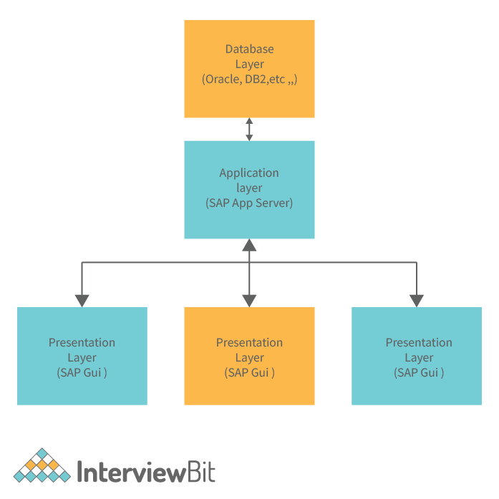

### **Application Layer**

This architectural layer is responsible for receiving and processing data prior to its usage by any component of the organization. This layer is also responsible for supplying application-specific data in the right format. The last duty of the application layer is to guarantee data security before passing it on to the next layer. This architectural layer is crucial to your digital transformation's success. The work procedure must be performed by a registered user of the system. Consequently, we characterize the work process as a system user. The work process will register itself in the database, and when a new record must be created in the system, the work process will do it. The system administrator can build the work process using the SAP system. In the SAP system, this is accomplished by assigning a specific value to the user's role. When you do this action, the SAP system will create a new user in the database system. This user will register themselves in the database, and if the system requires a new record to be created, this user can create it. When the system needs the user to create a new record via the work process, the user will construct the process.

### **Database Layer**

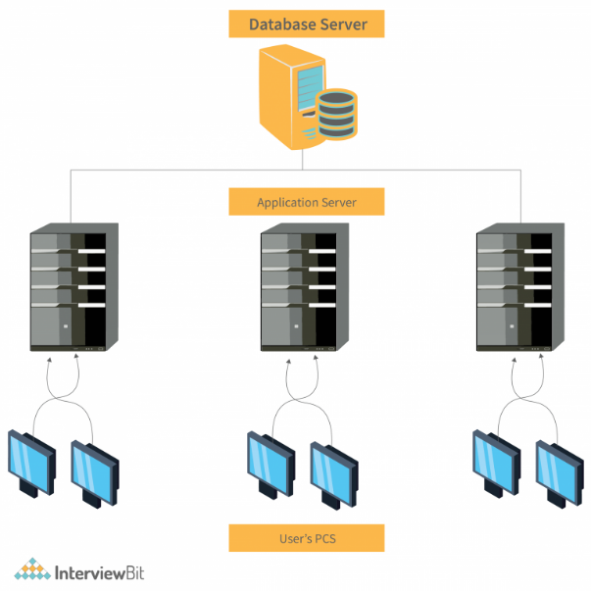The system architecture is what defines the structure of your SAP system. If you were establishing a new business, you would select a system architecture based on the sort of business you want to launch. A producer of bikes and scooters, for instance, would benefit most from a system architecture that prioritizes production and inventories. The optimal system architecture for a hotel would prioritize customer relations. After selecting the location for your new business, you must select the SAP system architecture. The application and database layers get information on presentation layer activities and subsequently query the results. As a result, processing results are visible on the presentation layer.

## **SAP Modules**

SAP contains numerous sub-functional modules that operate differently to help assign the operating system of each department. Each department is suitably able to respond to the job of that organization. These sub-functional units are called "modules." (Module) modules that are interesting and popular in use are:

* **Financial Accounting (FI)**

FI (Financial Accounting) is responsible for controlling the controlled flow of financial data throughout the firm and integrating all data for optimal strategic decision-making.

* **Controlling (CO)**

The SAP CO (Controlling) module allows the coordination, monitoring, and optimization of an organization's activities. It governs the organization's business flow. This module facilitates the comparison of actual figures to anticipated data and the creation of company strategy.

* **Production Planning (PP)**

SAP PP is an abbreviation for Production Planning and Control. This SAP ERP module is focused on the planning and execution of an organization's manufacturing business activities. Unlike other SAP ERP modules such as Financial Accounting or Materials Management, not all businesses choose to deploy the SAP PP module because it is only required if a business engages in manufacturing activities. However, because the majority of businesses include manufacturing units, SAP PP has features for managing production facilities and processes efficiently.

* **Material Management (MM)**

Material Management is concerned with material transportation through other modules like logistics, supply chain management, sales and delivery, warehouse management, production, and planning.

* **Human Capital Management (HCM)**

SAP human capital management (HCM) solutions meet your major workforce transformation needs by providing strategic, creative solutions for core HR and payroll, time and attendance, talent management, employee experience management, and people analytics.

* **Sales and Distribution (SD)**

SAP SD is one of SAP's most essential modules. The level of integration complexity is considerable. SAP SD is utilized by firms to support the sales and distribution of products and services, beginning with the inquiry, and concluding with the delivery. SAP SD can monitor a variety of business activities, including product inquiries, quotations (pre-sales activities), order placement, pricing, delivery scheduling (sales activity), picking, packing, goods issue, shipment of products to customers, delivery of products, and billings.

## **Important features**

* **Accounting and financial administration**

Streamline and automate financial management by integrating accounting, sales, and purchasing data into corporate software. Prepare to increase margins, decrease errors, and promote more lucrative decision-making.

* **Customer relationship management (CRM)**

Customer relationship management (CRM) is used to convert more prospects, maintain customer satisfaction, and maximize income. Our comprehensive CRM tools support all of your sales, service, and marketing activities, including campaign management, lead tracking, and after-sales support administration.

* **Warehouse and production management**

Real-time inventory management across numerous warehouses with cost-effective production. Our small business software may assist you in monitoring and recording stock movements, optimizing inventory levels, enhancing on-time delivery, and even eradicating stock-outs.

* **Purchasing and procurement**

Find innovative ways to save money by streamlining your whole purchasing procedure, including planning, order creation, vendor selection, invoicing, and payments.

* **Statistical reporting and analysis**

Enable employees to obtain real-time answers to their most pressing problems by providing them with rapid and simple access to intuitive business intelligence (BI), analytics, and reporting.

* **Supporting integrated business processes in your company**

## **How to use SAP tool**

**SAP tools**

The tools of this program are feature-rich and cover all functions of an organization that can effectively manage the business. The method of use is based on the image below that appears.

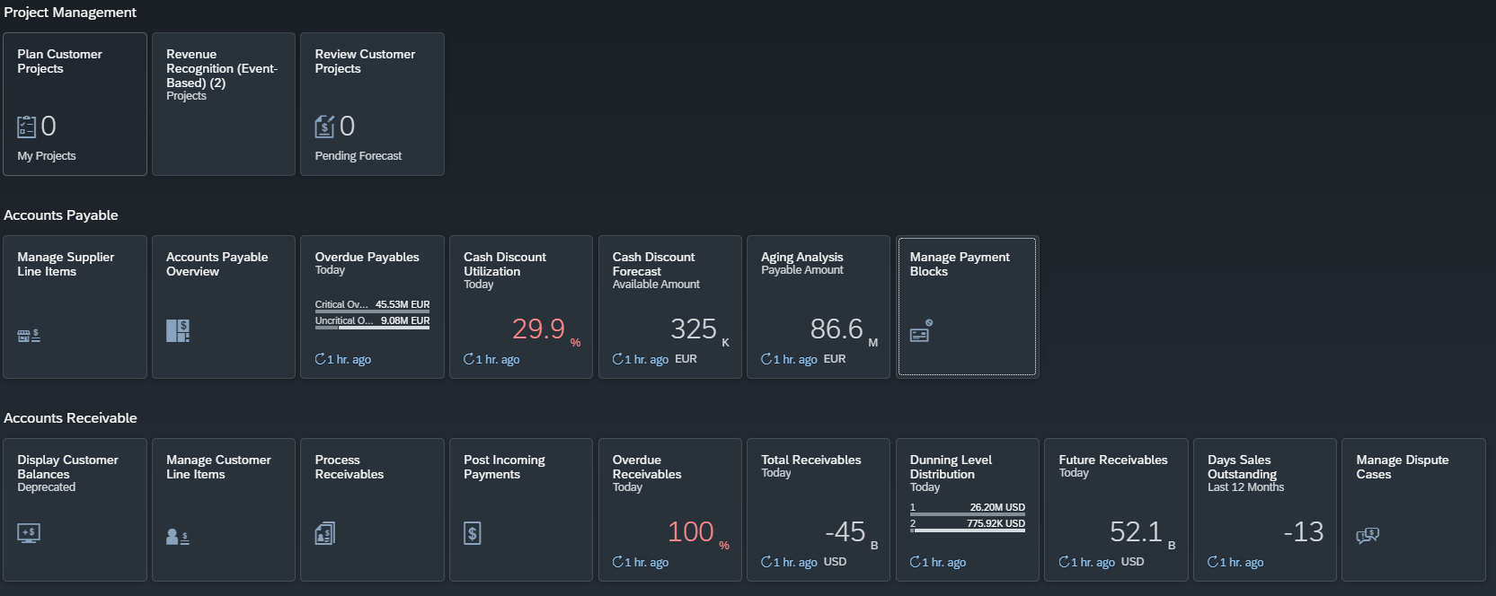

First, you must sign up for the account before using the website <https://www.sap.com/sea/products/erp.html> and fill in your information. After that, you will receive the email you entered to discover the SAP S/4HANA Cloud. When finished with the signup method, you must request a demo for enterprise resource planning in the next step. After that, you will receive access to your cloud trial in your registered mailbox. And log in to use them.

For example, if you need to create a custom project. You will choose Project Management and go to Plan customer projects following the picture below.

Next step, you must select the plus sign (+) on the bottom left of the sidebar and fill in the information following the request from the system.

From behind the picture, you will see the simple role you must fill in the empty block to complete the create Customer projects, but if you have another function. You can click the “Add project role on your right-hand side. After you finish, you will click the create button to complete

Following the picture below, your customer’s information will show like this.

Finally, you can edit or customize the element on the tools bar, such as work packages, Team roles or employees, or upload Attachments on this project. Following the three pictures below.

## **The Pros and Cons of SAP ERP Systems**

### **Pros**

* **More Rapid Decision Making**

Using the most up-to-date information and reporting capabilities, the SAP ERP system helps you to make crucial decisions fast. Since information about your daily operations is maintained in a consolidated database, you may quickly access all relevant factors while making a choice.

* **Reliable Data Sharing**

This solution will provide you with a consolidated database that facilitates the free flow of information across all company departments. Allowing you to avoid continually sending vital information to different departments separately. Since everyone has access to real-time data, this reduces the likelihood of information being distorted.

* **Enhanced Financial Administration**

A comprehensive enterprise resource planning (ERP) system enables end-to-end transaction tracking. This decreases the possibility of financial errors and embezzlement because correct data are provided.

* **Better Time and Money Management**

An ERP system helps you save money and time by automating and integrating all of your systems and procedures.

### **Cons**

* **Business Realignment**

The ERP system may not be compatible with your current company processes or systems, necessitating system re-engineering. Typically, this occurs when an organization employs obsolete systems.

* **High Integration Cost**

While it is advantageous to integrate all of your business's systems and procedures, integration might be prohibitively expensive. Therefore, you must collaborate with a seasoned system engineer to identify cost-effective integration strategies.

## **Company or organizations that use SAP**

|  |  |
| --- | --- |
| **Company Name** | **Website** |
| **FEMA** | **fema.gov** |
| **Johnson & Johnson** | **jnj.com** |
| **Cisco** | **cisco.com** |
| **Tyson Foods, Inc** | **tysonfoods.com** |
| **Citrix** | **citrix.com** |
| **Colgate-Palmolive** | **colgatepalmolive.com** |
| **Dell** | **dell.com** |
| **Lorven Technologies** | **lorventech.com** |
| **Univera, Inc.** | **univera.com** |
| **CONFIDENTIAL RECORDS, INC.** | **confidentialrecordsinc.com** |
| **ConAgra** | **conagrabrands.com** |
| **BASF North America** | **basf.com** |
| **Burger King** | **bk.com** |
| **3M** | **3m.com** |
| **Coca-Cola** | **Coca-cola.com** |
| **Mini Melts, Inc.** | **minimelts.com** |
| **Plascore Inc.** | **plascore.com** |
| **David Leadbetter Golf** | **Leadbetter.com** |
| **QALO** | **qalo.com** |
| **Skullcandy** | **skullcandy.com** |

# **Tool 2 – Odoo**

## **Software architecture**

### **Presentation tier**

The top-most level of the application is the user interface. The main function of the interface is to translate tasks and results into something the user can understand.

### **Logic tier**

This layer coordinates the application, processes command, makes logical decisions and evaluations, and performs calculations. It also moves and processes data between the two surrounding layers

### **Data tier**

Information is stored and retrieved from a database or file system. The information is then passed back to the logic tier for processing, and then eventually back to the user.

## **Odoo Modules**

1. Odoo Accounting
2. Odoo Inventory and Manufacturing
3. Odoo Sales
4. Odoo Marketing
5. Odoo Human Resource
6. Odoo Productivity
7. Odoo Shipping
8. Odoo Services
9. Odoo Website

## **Important features**

A suite of business management software tools including, for example, CRM, e-commerce, billing, accounting, manufacturing, warehouse, project management, and inventory management and every feature of Odoo in the picture below.

## **How to use Odoo tool**

1. Go to the website <https://www.odoo.com/page/all-apps> and select the features that you want. This is the website homepage when you entered.

2. For example, Accounting and this is accounting dashboard you can choose what you want to do such as cash, bank, customer invoices.

3. You can choose features of accounting that you want. For example, choose customer invoices by click on “NEW INVOICE”.

4. In this case, you can create customer invoices will know that trading with any customer by fill in customer name and enter product name with more information such as label, account, quantity, price and taxes. Finally, system will calculate subtotal of that product and click confirm button.

5. After confirmed, you can click on “Customer invoices” again for checking invoices history when you add or delete and in this page show payment status to tell if this list is finished or not.

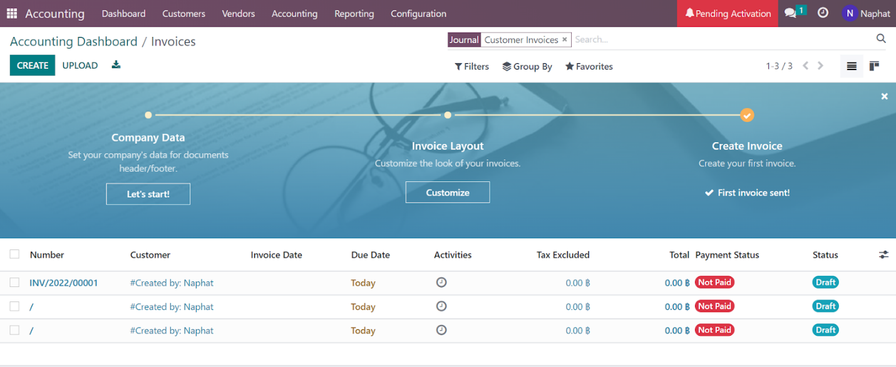

6. In optional, you can set your company’s data for document that contain general information and your company currency that easy to calculate and store information.

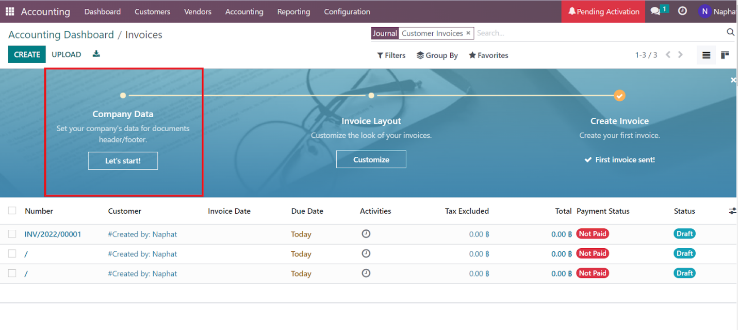

And this is form of company data that you can fill in.

7. In the accounting dashboard, you can add your financial accounts or bank account in seconds by click this button.

And its show worldwide or only Thailand bank institution.

8.Finally, every feature in accounting dashboard or any features in Odoo have export button when you want to download your information and in this case download into excel form.

## **The Pros and Cons of Odoo ERP Systems**

### **Pros**

* Easy to extend and develop
* Fully cloud-based
* Has a wide feature set that can be tailored to your department
* The system specifically to your business requirement.
* Integration of Services

### **Cons**

* Lack of support
* Hard to maintain
* Complicated pricing plans
* Narrow scope of support
* Complex set-up structure

## **Company or organizations that use Odoo**

In fact, there are companies that use Odoo around 223 companies so, give examples:

Top 8 Successful Companies Using Odoo 2022

1. Toyota
2. DelMonte Philippines
3. Sodexo
4. WWF
5. Kasetsart University (KU)
6. Advanced Biological Laboratories
7. Bazile Telecom
8. Qatar Investment Authorirt

# **Tool 3 – Microsoft Dynamics 365**

## **Software architecture**

The diagram shows a high-level architecture of Microsoft Dynamic 365 which consist of Microsoft Dynamics AX components, and these components can be installed on either a single physical server or multiple physical servers. This architecture will separate the main components into sections and each section linked to each other by arrows that show the direction of processes.

### **Application object server (AOS)**

AOS is a core component of the Microsoft Dynamics AX installation and is installed by using Setup. AOS enforces security to control connections between clients and the database and provides the framework where Microsoft Dynamics AX's business logic is executed.

### **Enterprise Portal**

Enterprise portal is provided by Microsoft Dynamics AX to enable clients to participate in business processes by using web-based forms, so that clients can access the information of the provided website.

### **Enterprise Search**

Users of Microsoft Dynamics AX can utilize the Enterprise Portal or the Microsoft Dynamics AX client to search through data, metadata, and documents that are attached to records.

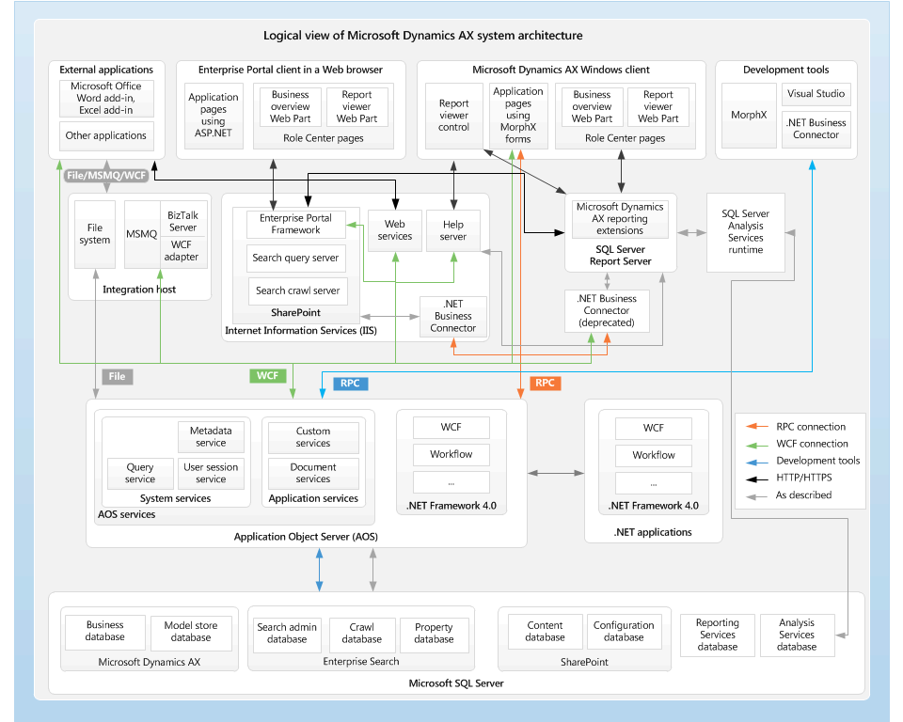

**The figure of Software Architecture of Microsoft Dynamics 365**

## **Software modules**

Microsoft Dynamics 365 allows users to select modules to adapt the software to their needs. Microsoft dynamic 365 provided these following tools for users:

* Business Central

Microsoft Dynamics 365 Business Central is an all-in-one ERP solution for small and medium-sized businesses which provides a system that integrates your business, boosts its effectiveness, automates operations and procedures, and gives users access to all their data through a single interface.

* Sales

The module has been created to make sales easier to manage a cohesive sales process within users’ company to transform company relationships into tangible turnover.

* Customer Service

  Any business interested with providing after-sales support should use this module. Built-in intelligence provides quicker, more individualized service and enhances every interaction, even while the user is on the go.

* Field Service

Dynamics 365 for Field Service is a built-in intelligence tool that helps users to resolve service issues before they occur, reduce operational costs, and deliver positive onsite experiences.

* Marketing

 The marketing modules helps turn prospects into business relationships and connections, whether company are a storefront business, online business, or a combination of both. The modules is to increase company marketing ROI, connect sales and marketing, automate procedures, and take better decisions.

* Project Automation

 This module was created for project management teams. It enables you to accelerate growth by optimizing project management and the profitability of ongoing projects, while sticking to budgets and increasing your collaborators’ productivity.

* Finance and Operations

 One of an Enterprise resource planning (ERP) software as a service (SaaS) service, is Finance and Operations applications, are created on and for Microsoft Azure. Without needing enterprises to manage infrastructure, the Finance and Operations service provides customers ERP capability that meets their specific needs and helps in adapting in rapidly changing business environments.

* Supply Chain Management

 Dynamics 365 Supply Chain Management manages the life cycle of all processes in the supply chain. It ends with a finished, manufactured item that is ready for either a customer or another phase of production. Each step in the life cycle requires different kinds of information to complete the process. As each step is completed, it will show a change in the production status. Thus, different types of products require different manufacturing processes.

* Commerce

 This module has been created as ideal for retailers. The application enables users to unify their company’s in-store and back-office operations. It enables retailers to create exceptional and innovative shopping experiences.

* Human Resources

  Microsoft Dynamics 365 for talent empowers user's HR team and personnel managers with the tools they need to hire the best candidates and accelerate their success.

## **Important features**

1. Sales insights

Dynamic365 can provide complete and intelligent information. The Relationship Insights feature analyzes a large amount of data from users CRM emphasizing on trends and opportunities for the development of customer accounts. With the analytical algorithms offered by Dynamics 365, it is possible to receive the most relevant customer information at any given time.

Dynamic 365 analyzes users’ communications and activities, the assistant will guide users through their daily priorities and keep in control of users opportunities.

1. Mobility

Dynamics 365 provides dashboard for mobile version makes this application particularly interesting. The interface of Dynamic 365 allows users representatives to access all their activities and contacts easily to all users. This feature allows managers to receive real-time customer interactions alerts and gives them a complete overview of sales channels. Due to the efficiency improvements, it enables within teams that are increasingly infrequently located in the same workplace, this tool provides a major advantage for businesses that have a propensity to become unstructured.

1. Connected to LinkedIn Sales Navigator

The integration between Dynamics 365 and LinkedIn, allows users to access the LinkedIn profiles of user’s prospects directly from their CRM solution. With Dynamics 365 analytics enabling users to get important data, improve target recommendations, and prioritize chances to increase target customer numbers.

1. Email integration with Outlook 365

The outlook 365 application allows user's CRM to fully integrate with their Microsoft email management software. It gives users access to all the chances and information related to the contact they are emailing

1. Customer service dashboard

The customer service dashboard gives managers access to the most pressing cases including the status of the request made as well as the most obvious opportunities to improve operations

1. Activity log and connections to CRM

Dynamic 365 offered the sensible information that your CRM can contain to its users. It is the activity log which records and holds all the connections and actions that are carried out also be integrated with other security systems such as Microsoft OMS and Splunk preventing intrusion or fraud of users CRM.

1. Smart search feature

Since Dynamic 365 can support more than just one work and sales team so the smart search feature was made for possibility to find information through all records, contacts, templates, and stored opportunities. The intelligence behind the search engine makes it possible to find better and faster information, saving your teams a considerable amount of time. Additionally, this function gives access to information that reps might not have known existed and that might be more important than the details they were initially looking for.

## **How to use Microsoft Dynamics 365 tool**

Microsoft dynamic 365 allows users to manage their ERP with its features and modules to meets its user’s needs. The application's features and modules can manage and plan a wide variety of fields and cover the entire organization from start to finish. Users of Microsoft Dynamics 365 can work both installs locally on their device and through the website.

* First, users go to the website in the <https://dynamics.microsoft.com/en-us/> website then sign in but if not have, users must register with the website first to make an application allows to access the tools of the website.
* As from the picture below, users are able to use tools that separate as sections on the navigation bar that displayed on the left-hand side.

* As from the picture below, users can select to use each tool and feature on the application to manage their ERP such as segments, measures, data, and etc.
* An example of numbers of customers by demonstrated as bar chart.

## **Pro and Cons**

### **Pros**

* The Low-code platform is easy to use and configure to users’ exact needs.
* It is integrated with the Microsoft products, so it will be more convenient for users to use this application.
* The application tool can perfectly work from finance to marketing, sales, meetings, and customer service, all business processes are fully integrated and work seamlessly together.
* As data from all sources is combined into a single source of truth, access strong analytics and business insight.

### **Cons**

* Since Dynamics 365 provides very low data storage limits, users have to purchase for more data storage which adds to users total cost of ownership.
* The system itself and some customizations can be quite costly, it take advantage of a trial before users buy to ensure the right solution for their needs and budget.
* There are some errors in mobile application version and does not offer all features. It's having difficulty connecting to certain apps and tools while using the mobile app.

## **Company or organizations that use them**

Companies mainly relying on Office 365 and outlook, or which runs on Azure provides beneficial integration with MS Dynamics 365. These following lists are companies and organizations that use Microsoft Dynamic 365 to manage their ERP and CRM by using option from Dynamics 365 such as customer insights, finance and operations, retail, project automation, marketing, etc.

1. Otis Elevator Co.
2. Vanguard
3. Selective Insurance
4. Saia Inc.
5. U.S. Department of Veterans Affairs
6. Sempra

# **A Comparison table of the tools**

|  |  |  |  |
| --- | --- | --- | --- |
| **Features** | **MS Dynamics 365** | **Odoo** | **SAP** |
| Mobile | 🗸 | 🗸 | 🗸 |
| Human Resources | 🗸 | 🗸 | 🗸 |
| CRM | 🗸 | 🗸 | 🗸 |
| Finance | 🗸 | 🗸 | 🗸 |
| IT | 🗴 | 🗴 | 🗸 |
| Warehouse MGMT | 🗸 | 🗸 | 🗴 |
| eCommerce | 🗸 | 🗸 | 🗴 |
| Cloud Deployment | 🗴 | 🗴 | 🗸 |
| Supply Chain | 🗸 | 🗸 | 🗸 |
| Asset MGMT | 🗴 | 🗸 | 🗸 |
| Procurement | 🗴 | 🗸 | 🗸 |
| Marketing | 🗸 | 🗸 | 🗴 |
| Integrations | 🗸 | 🗸 | 🗴 |
| CRM | 🗸 | 🗸 | 🗸 |
| Accounting | 🗴 | 🗸 | 🗸 |
| Sales | 🗸 | 🗸 | 🗸 |

# **Discussion**

In Report 2, we further research enterprise applications and ERP systems. The applications we study more thoroughly are three leading applications that many giant companies have trusted. The first application is SAP, a comprehensive functional and feature-rich application for use in business management with precision and stability. The second application we have studied is Odoo, a suite of software tools for managing enterprise business plans, including CRM, e-Commerce, Accounting, Project Management, etc. It has simple and well-displayed features for planning and management in the organization.

Moreover, for the selected tool, we chose ‘Microsoft Dynamics 365’ to study how to use its tools. We chose Dynamics 365 because it is the most widely used application that is a product from a top software company like Microsoft. With the flexibility of Microsoft Dynamic 365, it provides flexibility and usability that is easy to understand, uncomplicated, and easy to access. It is constantly updated to match the current business situation. Another reason for choosing Dynamic 365 is that this application has a similar level of ability compared to SAP and Odoo. In addition, we have compared the differences between each application to see the comparison and contrast between each tool.

# **Conclusion**

In conclusion, enterprise applications are designed to integrate the computing systems used at all stages of an organization to facilitate collaboration and coordination of tasks throughout the organization. Enterprise application development must meet the needs of business organizations that require more than meticulous planning and skill. As a company grows, it may face significant scaling issues, posing a formidable obstacle that is difficult to handle without incurring losses. The challenge of enterprise applications is managing data across the entire organization while maintaining security. The Enterprise application allows users to manage their organization with Enterprise Resource Planning (E.R.P.) systems. The concept of E.R.P. systems is an integrated business management software system that can efficiently manage and interpret data and information from all business processes. The key to a successful ERP deployment is achieving the right balance between technology and people. The business value of ERP systems is their ability to create a seamless integration of business processes within the organization to improve workflow and provide real-time and accurate information for users. In Report 2, as mentioned, three ERP and enterprise application tools are mentioned, which are SAP, Odoo, and the selected tool named Microsoft Dynamics 365. SAP and Odoo have similar software architectures, which have three layers of software, while Dynamics 365 has a more complicated architecture. In the comparison table, Dynamics 365 and Odoo have similar tools but with a bit of a difference in that Odoo has Asset MGMT, Procurement, and accounting tools while Dynamics 365 does not. On the other hand, SAP has a tool for the IT field while other applications don't, but SAP does not have most of the tools that both Dynamics 365 and Odoo have available for its users. Finally, Odoo should be suitable for covering all aspects of a large organization with a more complex system of operation than other applications.

# **References**

[1] “Best ERP Software & Tools in 2022 | TechnologyAdvice,” *TechnologyAdvice*, Oct. 13, 2022. [Online]. Available: [https://technologyadvice.com/erp/.](https://technologyadvice.com/erp/.%20)   
[2] “What is Odoo Enterprise? | OBS Solutions,” *OBS Solutions GmbH*. [Online]. Available: <https://www.odoo-bs.com/odoo-enterprise.>  
[3] buck1ey, “Dynamics 365 documentation and training modules,” *Dynamics 365 documentation and training modules | Microsoft Learn*. [Online]. Available: [https://learn.microsoft.com/en-us/dynamics365/.](https://learn.microsoft.com/en-us/dynamics365/.%20)

[4] NetSuite.com, “8 ERP Trends for 2022 | NetSuite,” *Oracle NetSuite*, Sep. 23, 2022. [Online]. Available: [https://www.netsuite.com/portal/resource/articles/erp/erp-trends.shtml.](https://www.netsuite.com/portal/resource/articles/erp/erp-trends.shtml.%20)

[5] N. & Associates, “Business Value of ERP Systems | Learn What Determines the Success of ERP For a Business at Nestell & Associates,” *Nestell & Associates*, Mar. 08, 2022. [Online]. Available: [https://nestellassociates.com/what-is-the-value-of-erp/.](https://nestellassociates.com/what-is-the-value-of-erp/.%20)

[6] “ERP Trends 2022 | Future of Enterprise Resource Planning,” *ERP Trends 2022 | Future of Enterprise Resource Planning*, Sep. 30, 2022. [Online]. Available: [https://www.selecthub.com/enterprise-resource-planning/erp-trends/.](https://www.selecthub.com/enterprise-resource-planning/erp-trends/.%20)

[7] “Advantages and disadvantages of ODOO ERP,” *Advantages and disadvantages of ODOO ERP*, May 31, 2021. [Online]. Available: [https://www.e2enetworks.com/blog/advantages-and-disadvantages-of-odoo-erp.](https://www.e2enetworks.com/blog/advantages-and-disadvantages-of-odoo-erp.%20)

[8] “Chapter 1: Architecture Overview — Odoo 16.0 documentation,” *Chapter 1: Architecture Overview — Odoo 16.0 documentation*. [Online]. Available: [https://www.odoo.com/documentation/16.0/developer/howtos/rdtraining/01_architecture.html.](https://www.odoo.com/documentation/16.0/developer/howtos/rdtraining/01_architecture.html.%20)

[9] bista-admin, “Odoo modules. The complete list of Odoo modules.,” *bistasolutions*, Jan. 10, 2019. [Online]. Available: [https://www.bistasolutions.com/resources/blogs/odoo-modules-list/.](https://www.bistasolutions.com/resources/blogs/odoo-modules-list/.%20)

[10] “Top 8 Successful Companies Using Odoo in 2022 - Solvve,” *Solvve*, Jun. 02, 2022. [Online]. Available: [https://solvve.com/blog/top-8-successful-companies-using-odoo-in-2022/.](https://solvve.com/blog/top-8-successful-companies-using-odoo-in-2022/.%20)

[11] Khairunj, “System architecture | Microsoft Learn,” *System architecture | Microsoft Learn*, Nov. 29, 2021. [Online]. Available: [https://learn.microsoft.com/en-us/dynamicsax-2012/appuser-itpro/system-architecture.](https://learn.microsoft.com/en-us/dynamicsax-2012/appuser-itpro/system-architecture.%20)

[12] “An Overview of the Different Modules of Microsoft Dynamics 365 - Gestisoft,” *An Overview of the Different Modules of Microsoft Dynamics 365 - Gestisoft*. [Online]. Available: [https://www.gestisoft.com/blog/an-overview-of-the-different-modules-of-microsoft-dynamics-365.](https://www.gestisoft.com/blog/an-overview-of-the-different-modules-of-microsoft-dynamics-365.%20)

[13] “Dynamics 365 : Features & Benefits - XRM Vision,” *XRM Vision*, Jan. 25, 2018. [Online]. Available: [https://xrmvision.com/en/blogue/a-few-essential-features-of-dynamics-365/#.](https://xrmvision.com/en/blogue/a-few-essential-features-of-dynamics-365/%23.%20)

[14] A. Stage, “Microsoft Dynamics 365 Advantages & Disadvantages | WayPath,” *WayPath*, Jul. 07, 2021. [Online]. Available: [https://waypathconsulting.com/microsoft-dynamics-365-pros-cons/.](https://waypathconsulting.com/microsoft-dynamics-365-pros-cons/.%20)

[15] “List of Companies using Microsoft Dynamics 365, Market Share and Customers List,” *InfoClutch*, Aug. 01, 2022. [Online]. Available: [https://www.infoclutch.com/installed-base/enterprise-application/microsoft-dynamics-365/.](https://www.infoclutch.com/installed-base/enterprise-application/microsoft-dynamics-365/.%20)